**Task – 3**

**SQL for Data Analyst**

**Orders Table Creation and Data Insertion**

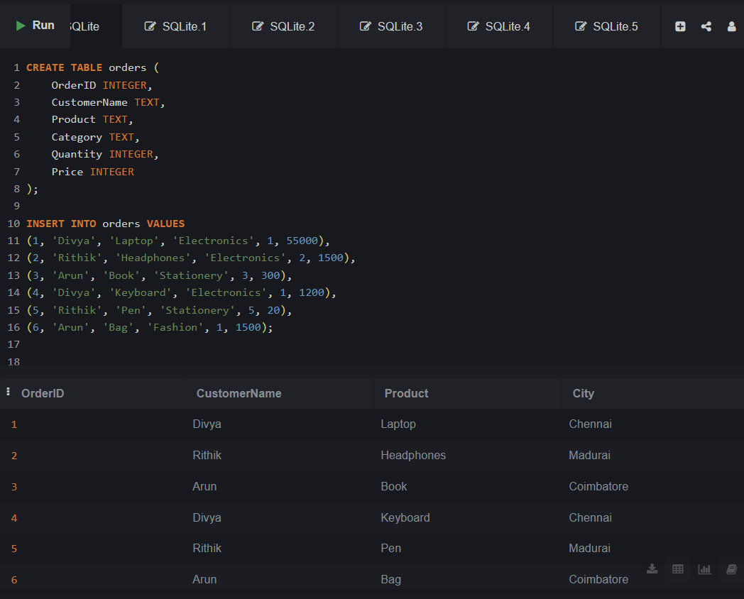

**Filtering Products Above Rs.1000**

* **SELECT + WHERE + ORDER BY**

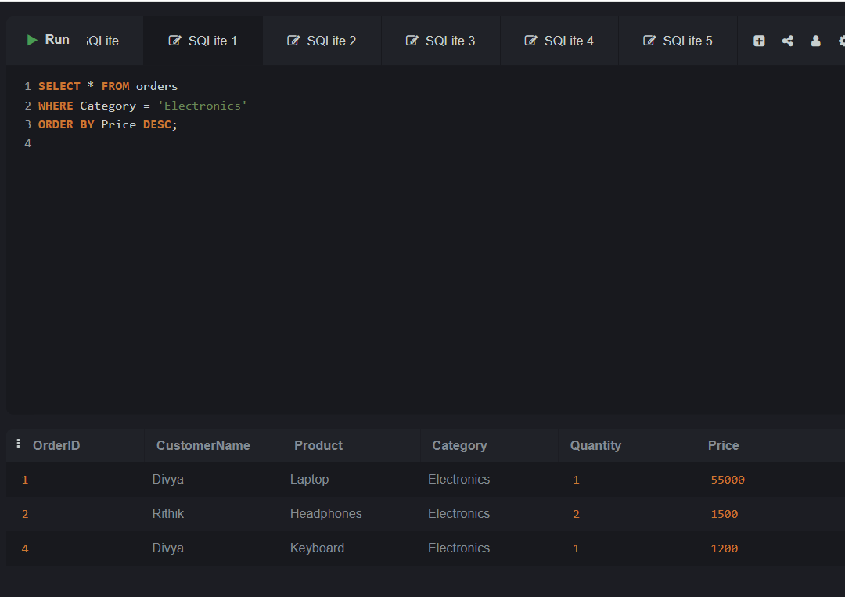

📌**Description**:  
This query retrieves all orders under the *Electronics* category and displays them in descending order of price — to identify the highest-priced items first.

**Sorting Orders by Price**

* **GROUP BY + Aggregate (SUM)**

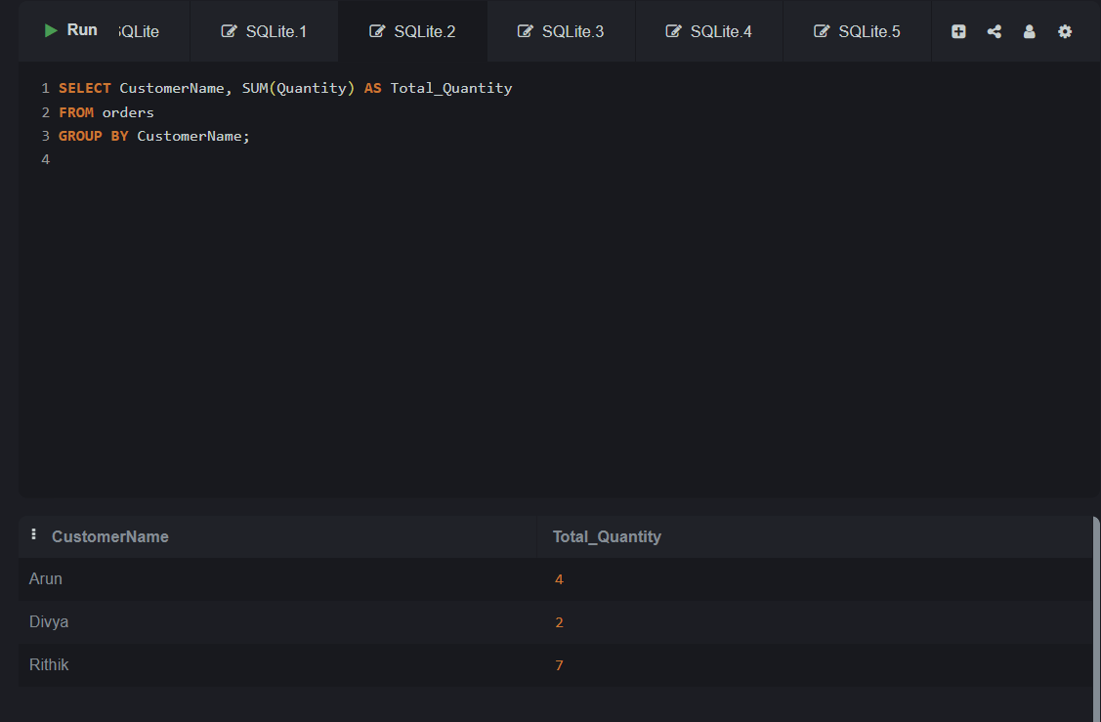

📌**Description**:  
This query shows the total number of products purchased by each customer by grouping the orders and summing up their quantities.

**Displaying Specific Columns (Customer & Product)**

* **Subquery**

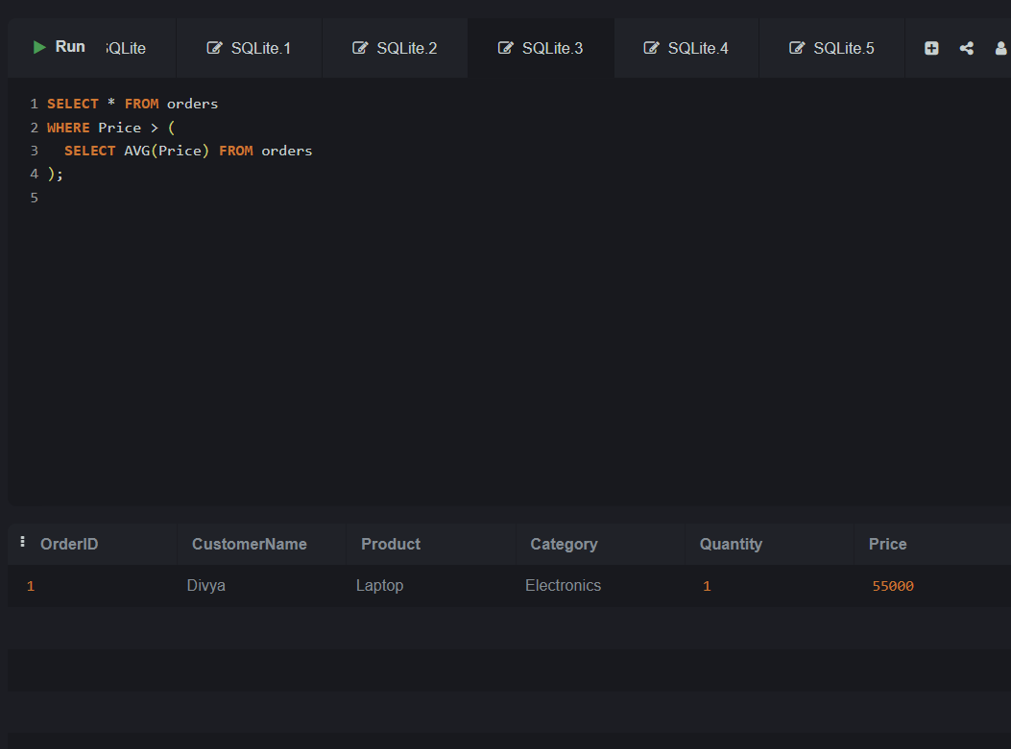

📌**Description**:  
This query selects only those orders whose product prices are *above the average price* of all products in the table.

**Creating a View for High-Value Orders**

* **Create a View**

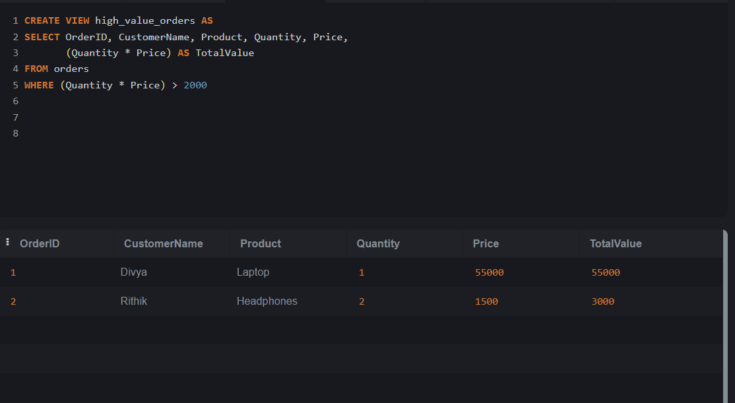

📌**Description**:

This query creates a **view named high_value_orders** that displays only the orders where the total value (Quantity * Price) is greater than 2000. It helps to **filter and track high-value purchases** efficiently.

**Inner Join Between Orders and Customers**

* **JOIN with another table**

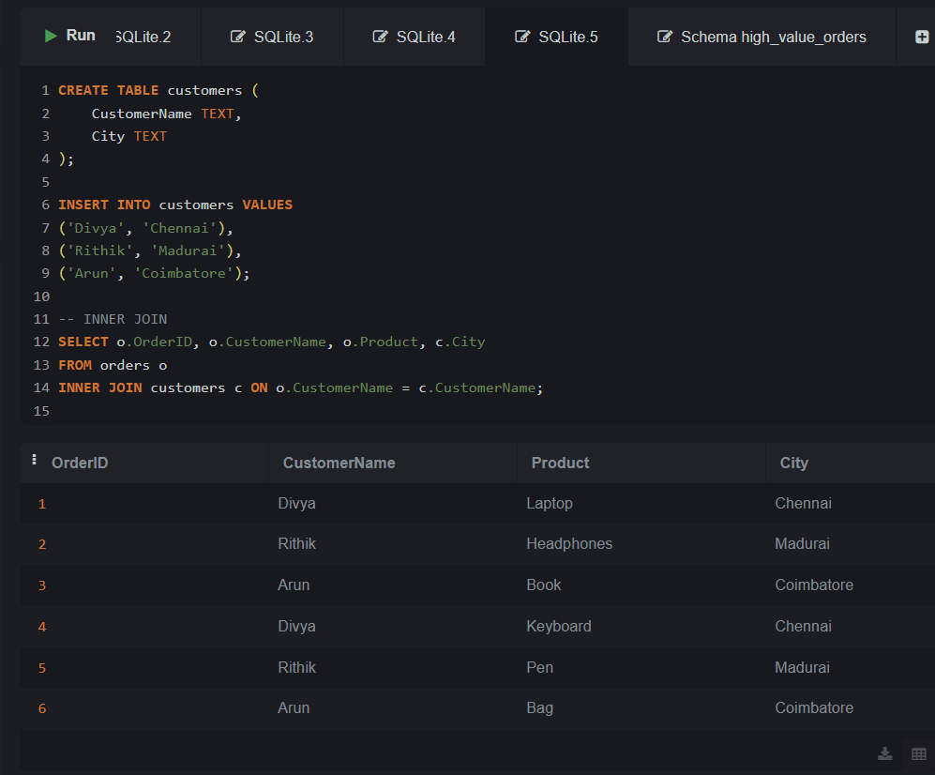

📌**Description**:  
This query joins the orders table with a customers table to display which customer placed which order **along with their city**, by matching names.